AI TRAINING – DAY 3 ASSIGNMENT
Python Operators & Strings: Manipulate → Extract → Clean → Format
Practical + MCQ + Debugging + String Utility Project

1. Learning Goals
- Understand arithmetic, comparison, logical, assignment and membership operators.
- Understand strings, indexing, slicing and common string methods.
- Use f-strings to create readable dynamic output.
- Identify common operator and string errors.
- Combine all topics to build a practical text utility.
- Explain your solution in your own words.

2. Assignment Rules
- Type the programs yourself. Do not copy complete solutions.
- Before running code, predict the output.
- Test strings with spaces, uppercase/lowercase, empty input and unexpected input.
- You may use AI to explain a concept or error after attempting it yourself.
- For every practical problem write Input → Processing → Output.
- Keep at least one error you faced and explain how you fixed it.

3. Part A – Operators Exploration
Create operators.py and experiment with each group. Write at least 2 examples for every group.
Operator group | Operators / your observation
Arithmetic | + - * / // % **  Observation: it is used to do calculations.
Comparison | == != > < >= <=  Observation: compare two values and give TRUE or FALSE as the result.
Logical | and or not  Observation: it is used to check conditions.
Assignment | = += -= *= /=  Observation: it is used to store or update values.
Membership | in / not in  Observation: in checks whether something exists, while not in checks whether something does not exist.
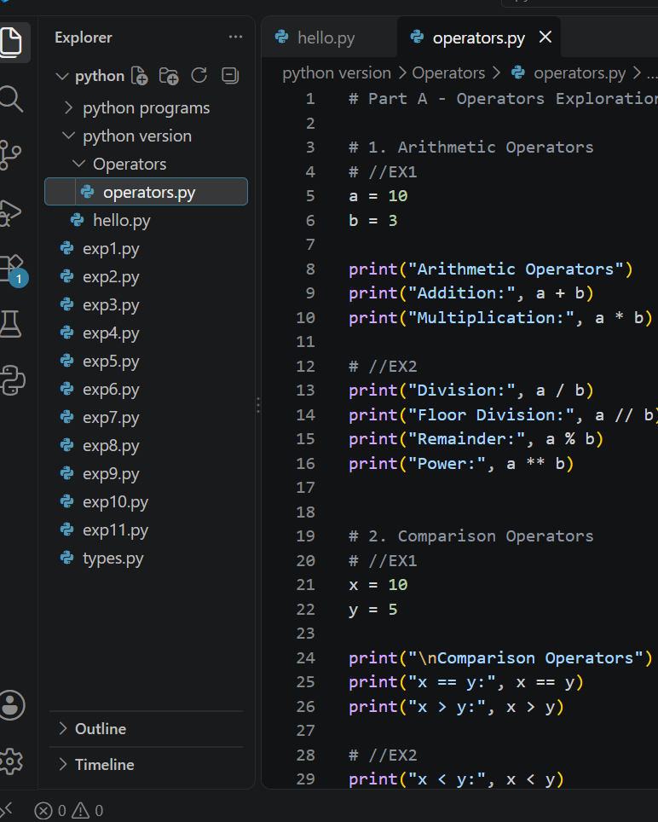

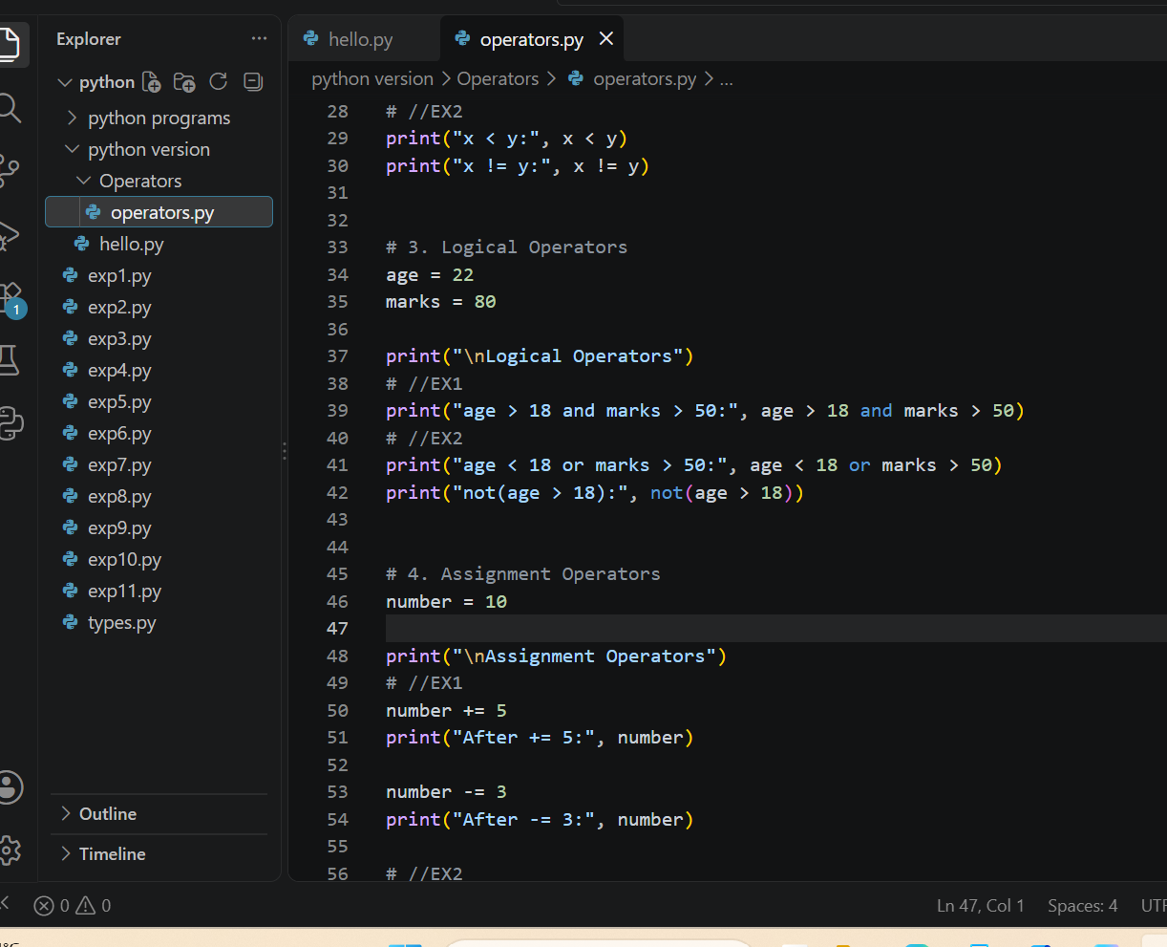

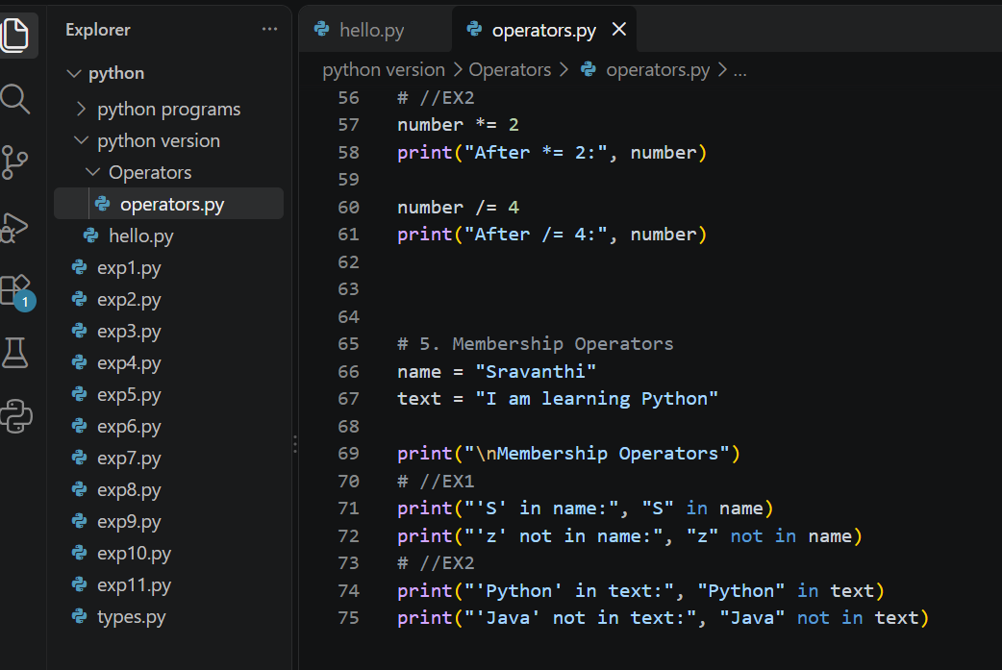
Output:

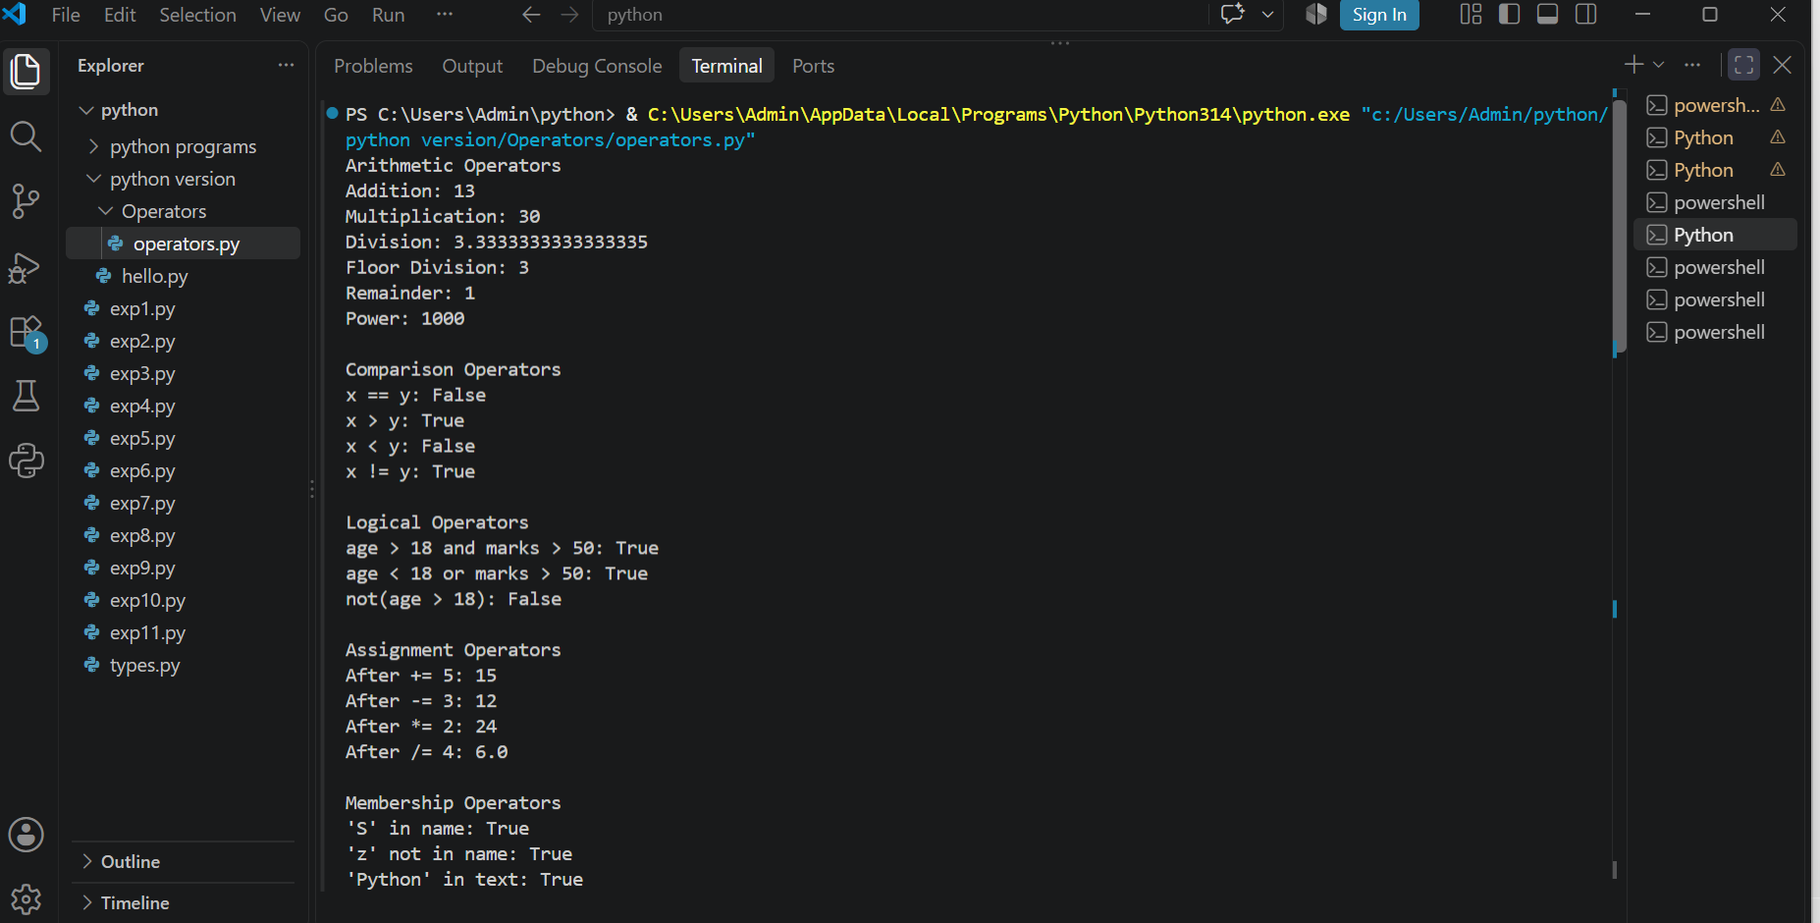

4. Part B – Operator Thinking
- What is the difference between / and //?
Ans: / is used for normal division and // gives only the floor value.
- When would % be useful in a real application?
Ans: % is used to find the remainder. For example, we can check whether a number is even or odd.
- What does ** do?
Ans: ** it is used to find the power of a number.
- What is the difference between = and ==?
Ans: = is used to give a value to a variable and == is used to comparision of two values are equal.
- What is the difference between != and not?
Ans: != is used to compare two values and not changes TRUE to FALSE and FALSE to TRUE.
- What is the result of 10 > 5 and 3 < 2? Explain.
Ans: 10>5 is True & 3<2 is False. TRUE and FALSE then the result is FALSE.
- What is the result of 10 > 5 or 3 < 2? Explain.
Ans: 10>5 is True & 3<2 is False. TRUE or FALSE then the result is TRUE.
- What does not True produce?
Ans: not True produces FALSE.
- What does 'Python' in 'I am learning Python' return?
Ans: it returns True because python is present in the sentence.
- When would not in be useful?
Ans: It is useful when you want to check that something doesn't exist.

5. Part C – String Basics Lab
Use your own name or another sentence and run these experiments.
- Create a string and print it.
Ans: name=”sravanthi”
Print(name)
Output: sravanthi
- Print its length using len().
Ans: name=”sravanthi”
Print(len(name))
Output: 9
- Print the first character using [0].
Ans: name=”sravanthi”
Print(name[0])
Output: s
- Print the last character using [-1].
Ans: name=”sravanthi”
Print(name[-1])
Output: i
- Print the first 3 characters using slicing.
Ans: name=”sravanthi”
Print(name[:3])
Output: sra
- Print the last 3 characters using slicing.
Ans: name=”sravanthi”
Print(name[-3:])
Output: thi
- Print every second character.
Ans: name=”sravanthi”
Print(name[::2])
Output: saati
- Reverse the string using slicing.
Ans: name=”sravanthi”
Print(name[::-1])
Output: ithnavars
- Try an invalid index. What error occurs?
Ans: name=”sravanthi”
Print(name[100])
Error: IndexError
- Try changing one character directly. What happens and why?
Ans: name= “sravanthi”
Name[0]=”M”
Error: TypeError
Because python strings are immutable.

6. Part D – String Methods Lab
Experiment with these methods and explain what each one does.
Method | Your example | What does it do?
lower() | name=”SRAVANTHI”  text=name.lower()  print(text) | Converts all letters to lowercase. like, sravanthi.
upper() | name=”sravanthi”  text=name.upper()  print(text) | Converts all letters to uppercase. Like, SRAVANTHI.
title() | name=”sravanthi patnam”  text=name.title()  print(text) | Converts the first letter of each word to uppercase. Like, Sravanthi Patnam.
strip() | name=” sravanthi patnam ”  text=name.strip()  print(text) | Removes spaces from the beginning and end of a string. Like, sravanthi patnam.
replace() | text=”I like mom”  result=text.replace(“mom”, “dad”)  print(result) | It changes one word into another. Like, I like mom to I like dad.
split() | text=”sravanthi is a beautiful girl”  result=text.split()  print(result) | It breaks a string into a list. Like, [‘sravanthi’, ‘is’, ‘a’, ‘beautiful’, ‘girl]
join() | words=[“sravanthi”, “is”, “best”]  result=”,”.join(words)  print(result) | It is opposite to the split(). Like, sravanthi is best.
startswith() | name=”sravanthi”  print(name.startswith(“sra”)) | Checks whether a string start with the given letters. Like, True.
endswith() | name=”sravanthi”  print(name.endswith(“thi”)) | Checks whether a string end with the given letters. Like, true.
find() | text = "I am learning Python"  print(text.find("Python")) | It gives the position where the given word starts.
count() | text=”hahahhhhhh”  print(text.count(“h”)) | It counts how many times repeated character.

7. Part E – Indexing & Slicing Challenge
Use: text = "Artificial Intelligence"
- Print the first character.
text=”Artificial Intelligence”
Print(text[0])
o/p: A
- Print the last character.
print(text[-1])
o/p: e
- Print the first 10 characters.
print(text[:10])
o/p: Artificial
- Extract the word Intelligence.
print(text[11:])
o/p: Intelligence
- Reverse the complete string.
print(text[::-1])
o/p: ecnegilletnI laicifitrA
- Print every second character.
print(text[::2])
o/p: Atfca netlgn
- Print characters from index 3 to 12.
print(text[3:12])
o/p: ificial I
- Find the index of the first 'i'.
print(text.find("i"))
o/p: 5
- Count the number of 'i' characters.
print(text.count("i"))
o/p: 4
- Predict what text[100] will do, then run it.
print(text[100])
It produces error because the string does not have an index 100.
Error: string index out of range.

8. Part F – f-Strings
- Create name, age and city variables and display them in one sentence using an f-string.
Ans: name=”sravanthi”
Age=20
City=”kanigiri”
print(f"My name is {name}. I am {age} years old and I live in {city}.")
- Create a product, price and quantity and display a formatted bill.
Ans: product=”phone”
Price=30000
Quantity= 2
Total=price*quantity
Print(f”product:{product}”)
Print(f”price:{price}”)
Print(f”quantity:{quantity}”)
Print(f”total:{total}”)

- Display student name, total marks and average.
Ans: name=”sravanthi”
Total_marks=950
Average=90.0
Print(f”student: {name}”)
Pritnt(f”total marks: {total_marks}”)
Print(f”Average: {average}”)
- Use an f-string to display a calculation result.
Ans: a=5
B=9
Result=a+b
Print(f”The sum of {a} and {b} is {Result}.”)
- Research decimal formatting and display a price with exactly 2 decimal places.
Ans: price= 125.5
Print(f”{price:.2f}”)

9. Part G – MCQs: Basic
1. Which operator means multiplication?
- A. x
- B. *
- C. %
- D. //
2. What does % return?
- A. Division
- B. Quotient
- C. Remainder
- D. Power
3. What is the first string index?
- A. 0
- B. 1
- C. -1
- D. first
4. What is len('Python')?
- A. 5
- B. 6
- C. 7
- D. Error
5. Which gets the last character?
- A. text[0]
- B. text[-1]
- C. text[last]
- D. text[1]
6. Which converts text to lowercase?
- A. lower()
- B. small()
- C. down()
- D. lowercase
7. Which removes leading/trailing spaces?
- A. trim()
- B. clean()
- C. strip()
- D. remove()
8. Which checks membership?
- A. inside
- B. in
- C. has
- D. contains
9. Which is an f-string?
- A. f"Hello {name}"
- B. "f Hello"
- C. format f(name)
- D. string(name)
10. Which compares equality?
- A. =
- B. ==
- C. ===
- D. equals

10. Part H – MCQs: Medium
1. What is 17 // 5?
- A. 3
- B. 3.4
- C. 2
- D. 4
2. What is 17 % 5?
- A. 3
- B. 2
- C. 3.4
- D. 0
3. What does 'Python'[1:4] return?
- A. Pyt
- B. yth
- C. ytho
- D. tho
4. What does 'Python'[-3:] return?
- A. tho
- B. hon
- C. yth
- D. Python
5. What does ' hello '.strip() return?
- A. ' hello'
- B. 'hello '
- C. 'hello'
- D. Error
6. What does 'hello'.upper() return?
- A. hello
- B. HELLO
- C. Hello
- D. Error
7. What does 'a,b,c'.split(',') return?
- A. abc
- B. ['a','b','c']
- C. ('a','b','c')
- D. Error
8. Which checks if AI occurs in text?
- A. text.contains('AI')
- B. 'AI' in text
- C. text.has('AI')
- D. contains(text,'AI')
9. What happens with text[50] when text has 10 characters?
- A. None
- B. ''
- C. IndexError
- D. False
10. Why use f-strings?
- A. Insert values/expressions into strings cleanly
- B. Make strings immutable
- C. Convert values to int
- D. Remove spaces

11. Part I – MCQs: Thinking
1. Which is true about strings?
- A. They can always be changed character-by-character
- B. They are immutable
- C. They only contain letters
- D. They cannot be sliced
2. Best way to clean ' PHANI gorantla ' for display?
- A. strip().title()
- B. title().strip()
- C. Both A and B
- D. clean()
3. What does text[::-1] do?
- A. Deletes text
- B. Reverses text
- C. Sorts text
- D. Gets first character
4. Best simple test for '@' in an email?
- A. '@' in email
- B. email == '@'
- C. email.contains('@')
- D. email.has('@')
5. replace() generally:
- A. Returns a transformed string
- B. Always changes the original string in place
- C. Converts to list
- D. Deletes the variable
6. x='5', y=2. Which gives numeric 10?
- A. x*2
- B. int(x)*2
- C. str(x)*2
- D. x+2
7. Which formats 12.5 as 12.50?
- A. f'{price:.2f}'
- B. f'{price:2}'
- C. f'{price.float}'
- D. f'{price.decimal(2)}'
8. What should usually happen before validating text entered with spaces?
- A. strip()
- B. reverse()
- C. split() always
- D. replace with None
9. A common cause of IndexError is:
- A. Invalid index
- B. Using an f-string
- C. lower()
- D. +
10. Why keep raw input and cleaned input conceptually separate?
- A. It makes transformations easier to test
- B. Python requires it
- C. Strings cannot be stored
- D. It prevents every error

12. Part J – 5 Practice Problems
Problem | Task | Topics
Practice 1 – Username Cleaner | Ask for a username, remove surrounding spaces, convert to lowercase and display the cleaned value. | strip + lower + f-string
Practice 2 – Name Formatter | Ask first and last names in random case and display a properly formatted full name. | strip + title + f-string
Practice 3 – Word Analyzer | Ask for a sentence. Display length, first character, last character, spaces count and vowel count. Do not use loops. | len + indexing + count
Practice 4 – Email Inspector | Ask for an email. Check '@', check whether it ends with '.com' or '.in', and show the position of '@'. | in + endswith + find
Practice 5 – Product Code Extractor | For code IND-MOB-2026-001, extract country, category, year and serial using slicing. | indexing + slicing + f-string
For each: Input → Expected Output → Code → 2 test cases → 1 edge case → explanation.
Practice 1- Username Cleaner
Input: Ask the user for a username.
Processing: Remove extra spaces and convert it to lowercase.
Code: username = input("Enter username: ")
cleaned = username.strip().lower()
print(f"Cleaned username: {cleaned}")
output: username should have no extra spaces and should be in lowercase.
Test Case 1:
Input: Sravanthi
Output: Cleaned username: sravanthi
Test Case 2:
Input: Asifa123
Output: Cleaned username: asifa123
Practice 2 – Name Formatter
Input: First name and last name in any case.
Code: first_name= input(“Enter first name:”)
Last_name=input(“Enter last name:”)
Print(f”full name: {first_name.strip().title()} {last_name.strip().title()}”)
Output: both names should starts with a capital letters.
Test Case 1:
Input: sravanthi
Output: full name: Sravanthi
Test Case 2:
Input: sravanthi, asifa
Output: full name: Sravanthi, Asifa
Practice 3 – Word Analyzer
Input: A sentence.
Output: length, first character, last character, number of spaces and number of vowels.
Code: text= input(“Enter a sentence:”)
Vowel_count=(text.count(“a”) + text.count(“e”) + text.count(“i”) + text.count(“o”) + text.count(“u”) + text.count(“A”) + text.count(“E”) + text.count(“I”) + text.count(“O”) + text.count(U”))
Print(f”length: {len(text)}”)
Print(f”first character: {text[0]}”)
Print(f”last character: {text[-1]}”)
Print(f”spaces: {text.count(‘’)}”)
Print(f”vowels: {vowel_count}”)
Test Case 1:
Input: Sravanthi
Output: length:9
First character: S
Last character: i
Spaces: 0
Vowels: 3
Test Case 2:
Input: Asifa
Output: length:5
First character: A
Last character: a
Spaces: 0
Vowels: 3
Practice 4 – Email Inspector
Input: An email address.
Output: Whether @ is present, whether it ends with .com or .in, and the position of @.
Code:
email = input("Enter email:")
conatins ="@"in email
valid_end = email.endswith(".com") or email.endswith(".in")
at_position = email.find("@")
print(f"Contains @: {conatins}")
print(f"Ends with .com or .in: {valid_end}")
print(f"Position of @: {at_position}")
Test Case 1:
Input: sravanthi@gmail.com
Output:
Contains @: True
Ends with .com or .in: True
Position of @: 9
Test Case 2:
Input: Asifa@yahoo.in
Output:
Contains @: True
Ends with .com or .in: True
Position of @: 5
Edge Case:
Input: sravanthigmail.com
Output:
Contains @: False
Ends with .com or .in: True
Position of @: -1

Practice 5 – Product Code Extractor
Input:
A product code like IND-MOB-2026-001.
Output:
Country: IND
Category: MOB
Year: 2026
Serial: 001
Code:
code = input("Enter product code:")
country = code[0:3]
category = code[4:7]
year = code[8:12]
serial = code[13:16]
print(f"Country: {country}")
print(f"Category: {category}")
print(f"Year: {year}")
print(f"Serial: {serial}")
Test Case 1:
Input: IND-MOB-2026-001
Output:
Country: IND
Category: MOB
Year: 2026
Serial: 001
Test Case 2:
Input: CAN-CAP-2025-025
Output:
Country: USA
Category: LAP
Year: 2025
Serial: 025
Edge Case:
Input: IND-TAA-2026-999
Output:
Country: IND
Category: TVX
Year: 2026
Serial: 999

13. Part K – Debugging Lab

Bug 1
name = input('Name: ')
print(name[20])
Why can this fail? Fix it.
Corrected code / explanation: name = input(‘Name:’)
Print(name[20])
It can fail if the entered name has fewer than 21 characters, index 20 does not exist. so,it gives IndexError.
Code:
name = input("Name: ")
if len(name) > 20:
print(name[20])
else:
print("The name is too short.")

Bug 2
age = '20'
print(f'Age: {age + 1}')
Fix it.
Corrected code / explanation: age is a string, but 1 is an integer. We cannot directly add a string and an integer.
Code: age = '20'
print(f'Age: {int(age) + 1}')

Bug 3
name = 'phani'
age = 30
print('Hello ' + name + age)
Identify the type problem and fix it.
Corrected code / explanation: name is a string and age is an integer. We cannot join them directly using +.
Code:
name = 'phani'
age = 30
print(f"Hello {name}, your age is {age}")

Bug 4
email = input('Email: ')
print(email.endswith('.com'))
Test with 3 inputs and explain.
Corrected code / explanation: This code works, but it only checks whether the email ends with .com.
Test 1:
Input: sravanthi@gmail.com
Output: True
Test 2:
Input: sravanthi@gmail.in
Output: False
Test 3:
Input: sravanthi@gmail.org
Output: False

Bug 5
code = 'IND-MOB-2026-001'
print(code[20])
Find the valid index range and fix the requirement.
Corrected code / explanation: The string has 16 characters, so the valid positive index range is: 0-15.
Code: code = 'IND-MOB-2026-001'
print(code[0])

Bug 6
text = ' hello world '
print(text.upper().strip())
Does it work? Explain the order of operations.
Corrected code / explanation: Yes, its work correctly.Text.upper converts text to uppercase. While strip() removes the spaces.
Code: text = ' hello world '
cleaned = text.upper().strip()
print(cleaned)

14. Part L – Main Project: Text-Cleaning & Profile Formatter
Build a practical Python program that accepts messy profile information and converts it into a clean, readable profile.

Scenario
A company receives profile data in inconsistent formats. Names may contain extra spaces, emails may use mixed cases, and cities may be entered randomly. Your program should clean the data and generate a professional profile summary.

Required Inputs
- Full name
- Email address
- Phone number
- City
- Job role
- Short bio

Must-Have Requirements
- Remove leading/trailing spaces.
- Format the full name using title().
- Convert email to lowercase.
- Format city and job role neatly.
- Calculate bio character count.
- Check whether the email contains '@'.
- Check whether the email ends with a supported domain such as .com or .in.
- Extract first name from the full name.
- Extract last name using string logic.
- Display the profile using f-strings.
- Show a small data-quality section.
- Test with messy uppercase/lowercase and extra spaces.

Expected Output Example
================ PROFILE ================
Name : Phani Gorantla
First Name : Phani
Email : phani@example.com
Phone : 9876543210
City : Hyderabad
Role : Software Developer
Bio Length : 42 characters
------------- DATA QUALITY -------------
Email Valid : Yes
=========================================
Do not hard-code the example. The program must work with any user's input.

15. Project Bonus Challenges
- Clean repeated spaces inside a name.
- Validate phone number length.
- Check that the full name contains at least two words.
- Generate initials from the name.
- Generate a username from the person's name.
- Create a one-line professional bio using an f-string.
- Display a simple data-quality percentage.
Code:
full_name = input("Enter full name: ")
email = input("Enter email: ")
phone = input("Enter phone number: ")
city = input("Enter city: ")
job_role = input("Enter job role: ")
bio = input("Enter short bio: ")

full_name = " ".join(full_name.strip().split())
email = email.strip().lower()
phone = phone.strip()
city = city.strip().title()
job_role = job_role.strip().title()
bio = bio.strip()

name_parts = full_name.split()

if len(name_parts) >= 2:
first_name = name_parts[0]
last_name = name_parts[-1]
else:
first_name = full_name
last_name = ""

formatted_name = full_name.title()
has_at = "@" in email
supported_domain = email.endswith(".com") or email.endswith(".in")

bio_length = len(bio)

print()
print("=============== PROFILE ===============")
print(f"Name : {formatted_name}")
print(f"First Name : {first_name}")
print(f"Last Name : {last_name}")
print(f"Email : {email}")
print(f"Phone : {phone}")
print(f"City : {city}")
print(f"Role : {job_role}")
print(f"Bio Length : {bio_length} characters")

print("------------- DATA QUALITY -------------")

if has_at and supported_domain:
print("Email Valid : Yes")
else:
print("Email Valid : No")

print("========================================")
Bottom of Form

16. Project Test Cases
Test | Input condition | Expected behaviour | Actual result
1 | Normal clean input | Clean profile | Profile displayed correctly.
2 | Extra spaces around fields | Spaces removed | Extra spaces are removed.
3 | Random uppercase/lowercase | Proper formatting | Text is converted into consistent format.
4 | Invalid-looking email | Flag data quality | Email was shown as invalid.
5 | Short/missing optional data | Program should handle it sensibly | Missing data handled without crashing.

17. Explain Your Project
- What is the difference between cleaning data and formatting data?
Ans: cleaning data means removing unwanted spaces and formatting means making the data look proper.
- Which string methods did you use and why?
Ans: I use lower() to convert email to lowercase and strip() to remove extra spaces at the beginning and end.
- Where did you use indexing?
Ans: I used indexing to access individual characters.
- Where did you use slicing?
Ans: slicing is used when we want a part of a string.
- Why are f-strings useful here?
Ans: f-strings make it easy to put variables inside a sentence to look more cleaner.
- What error did you face?
Ans: I faced an IndexError. It happened when I tried to access an index that did not exist.
- How did you test edge cases?
Ans: I tested the program with extra spaces, uppercase text and lowercase text.
- If this processed 1 lakh profiles, what would you improve first?
Ans: I would first improve data validation and performance.

18. Final Self-Check
Skill | Yes | Need Practice | Notes
Use arithmetic/comparison/logical operators | Yes | ☐ | Arithmetic operators are used for calculations, comparision operators are used to compare values and logical operators are combine conditions.
Explain = vs == | Yes | ☐ | = is assigns a value to a variable and == checks whether two values are equal.
Manipulate strings | Yes | ☐ | It can join, change & work with text strings.
Use positive and negative indexing | Yes | ☐ | Positive indexing starts from 0 and negative indexing starts from -1.
Use slicing | Yes | ☐ | Slicing is used to get a part of a string.
Use string methods | Yes | ☐ | It helps us work with text.
Use in/not in | Yes | ☐ | I can check whether a character present in a string.
Use f-strings | Yes | ☐ | f-strings are an easy way to combine text and variables.
Debug IndexError/type problems | Yes | ☐ | IndexError happens when we try to access an invalid index and TypeError happens when we use incompatiable data types.
Build the final text utility | Yes | ☐ | It is a small program that performs on text such as formatting text.

19. Submission Checklist
- Operator experiments
- Operator questions
- String exploration
- String-method table
- Indexing/slicing challenge
- f-string exercises
- 30 MCQ answers
- 5 practice programs
- Debugging Lab
- Text-Cleaning & Profile Formatter
- Project test cases
- Project explanation and self-check

